“Education is the most powerful weapon which you can use to change the world.”
-Nelson Mandela

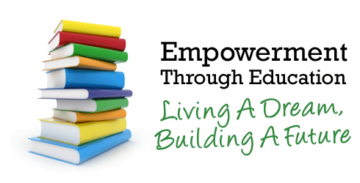

Help make a difference. Become a VITA volunteer tutor.
Tutors provide one-to-one instruction to adults who want to improve their reading, writing, math or English skills.

Tutor Training Workshop
Session 1: Tuesday, June 23, 2015 from 5:00 p.m. to 7:30 p.m.
Session 2: Thursday, June 25, 2015 from 5:00 p.m. to 7:30 p.m.
Session 1 is a prerequisite to Session 2

VITA
905 Jefferson Street Suite 404 Lafayette, La 70501 Register Today!

